Satyam Kumar Modi, 2019CS50448
Assignment-1

1. Linear Regression

1.a Learning rate : 0.01
Stopping Criteria: | J(θ^{t+1}) – J(θ^{t})| < ε where ε = 1e-10
Parameters learnt : Θ₀ = 0.99652102, Θ₁ = 0.00134006
MSE = 1.199698629377484e-06

1.b Hypothesis Function plot

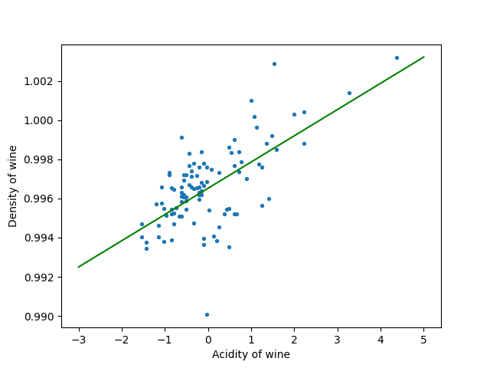

Fig. 1 : Hypothesis Function learned

1.c 3-D Mesh Plot of J(θ)

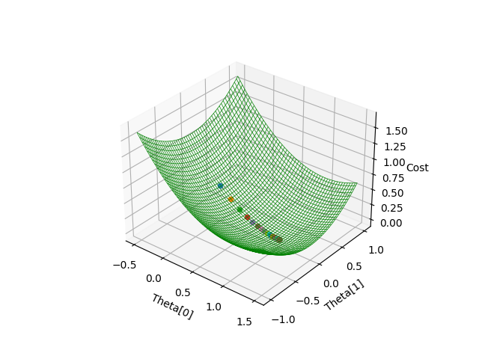

1.d Contour of the Error Function J(θ)

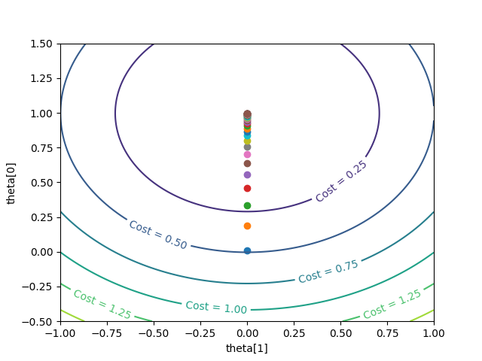

1.e Contour with varying learning rate

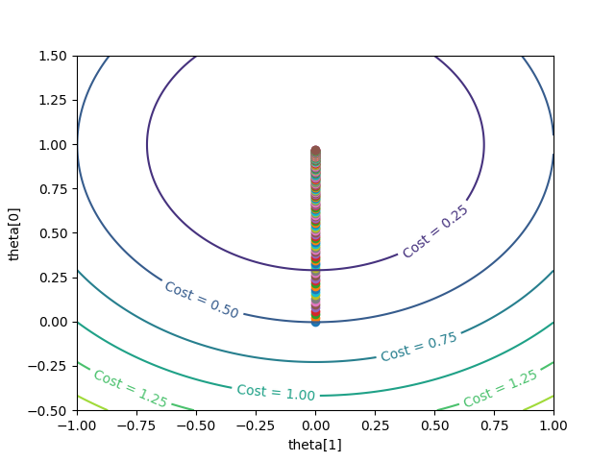

For learning rate = 0.0001

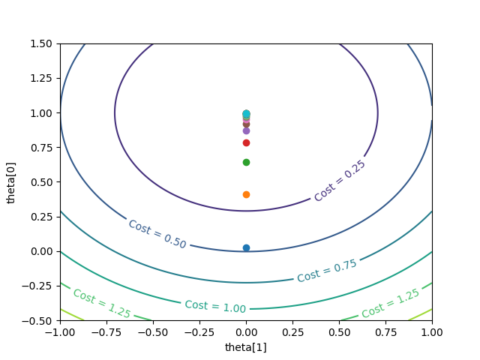

For learning rate = 0.025

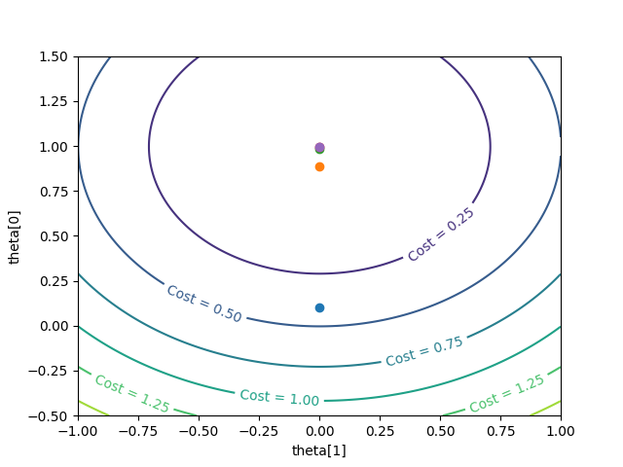

For learning rate = 0.1

The following could be inferred from the above plots:
As the learning rate increased from 0.0001 to 0.1, the steps taken by gradient descent got bigger in magnitude. Thus, we have the least number of steps taken before convergence in case of η = 0.1 and the most number of steps in case of η = 0.0001.

2. Stochastic Gradient Descent

2.a

Batch Size | θ learnt | Number of  Iterations | Time  Taken | Training loss | Test loss
1 | (3.037, 0.9618, 2.015) | 201000 | 3.67 sec | 1.006 | 1.067
100 | (3.004, 0.998, 2.001) | 201000 | 4.4 sec | 0.9996 | 0.983
10000 | (2.991, 1.001, 1.999) | 22000 | 3.5 sec | 1.001 | 0.983
1000000 | (2.967, 1.007, 1.998) | 16000 | 10 min. | 1.0005 | 0.985

2.b Convergence Criteria Used :

i. For b = 1, convergence criteria used was taking average loss per 1000 iterations and then
checking whether | J_{avg}(θ^{t+1}) – J_{avg}(θ^{t})| < ε where ε = 1e-5 but I had to keep and upper bound on the number of iterations which was 201000 as I observed that sometime the difference never got less than 1e-5.

ii. For b = 100, convergence criteria used was taking average loss per 1000 iterations and then
checking whether | J_{avg}(θ^{t+1}) – J_{avg}(θ^{t})| < ε where ε = 1e-5

iii. For b = 10000, convergence criteria used was taking average loss per 1000 iterations and then
checking whether | J_{avg}(θ^{t+1}) – J_{avg}(θ^{t})| < ε where ε = 1e-5

iv. For b = 1000000, convergence criteria used was taking average loss per 1000 iterations and then
checking whether | J_{avg}(θ^{t+1}) – J_{avg}(θ^{t})| < ε where ε = 1e-7

2.c No, for b=1 and 100, the observed value of the learned parameters were different. But for b = 10000 and b = 1000000, observed values for the learned parameters were almost same.

From the observations, it was noticed that for b = 1, the number of iterations taken were large as the update was performed after seeing every training example . This may have happenend because each time the parameters were updated taking only one training example into account. Due to this the direction of convergence may not have been always directed towards the global minima. When b was increased to 10000, we noticed a decrease in the number of iterations taken as more training example were now seen by the model before performing 1 update.

For the time taken, we noticed that for b = 1 and b = 100, when the model was near to the convergence point the model faced some re-directions in other direction (not towards global optima). Due to this, the iterations kept on increasing and then we had to keep an upper bound on the number of iterations. So, 201000 iterations took around 3.67 sec in case of b = 1. For b = 100, same situation arised in some cases. For b = 10000, since the number of iterations taken were less, the time taken was relatively lesser than the case of b = 1 and b = 100. For b = 1000000, it took the maximum time because in each iteration it had to run 1 million training examples. Though the number of iterations taken were less than b = 10000, this may have been because since each iteration was seeing much larger data convergence point was reached in lesser number of steps.

The test loss was highest in the case of b = 1. Then, it remained almost same for b = 100, 10000 and 1000000. The test loss might have been high in case of b = 1, as the algorithm had not seen all 1 million data before convergence.

2.d

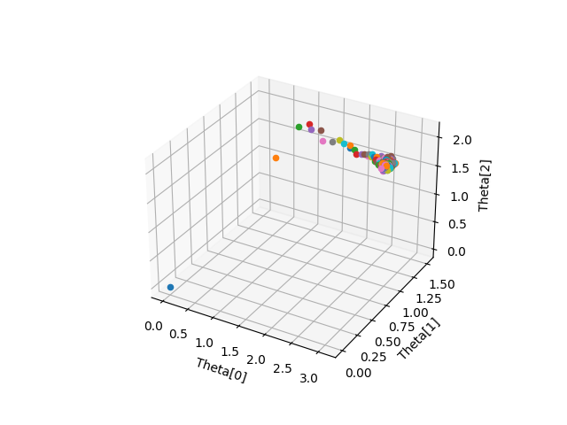
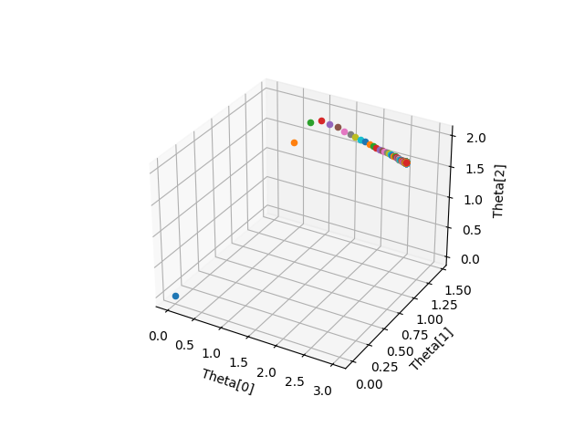

b = 1 b = 100

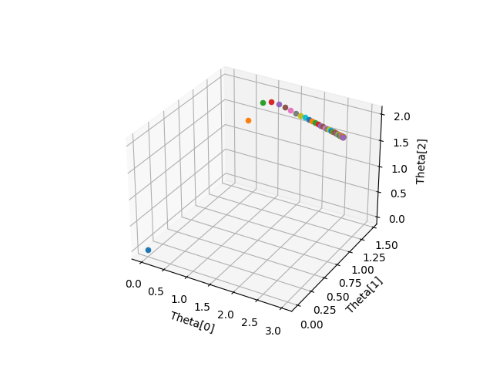
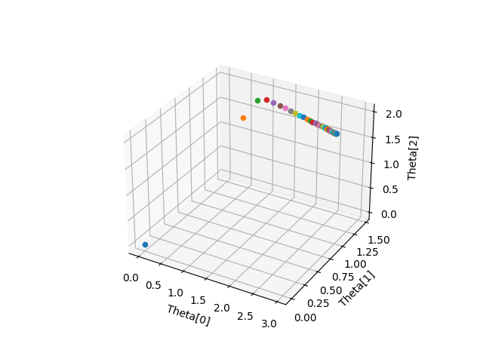

b = 10000 b = 1000000

The plots of learned parameters can be described as for b = 1, the θ values kept moving within the vicinity of the convergence point. But for b = 100, 10000, 1000000, the graphs were much similiar. This was because of as more training examples were seen per iteration the movement got more directed towards the global optima.

3. Logistic Regression

3.a Results

Using Newton Raphson method to optimize L(θ), paramters obtained are:
Θ₀ = 0.40125316, Θ₁ = 2.5885477, Θ₂ = -2.72558849

3.b Plot of the labelled classes with decision boundary

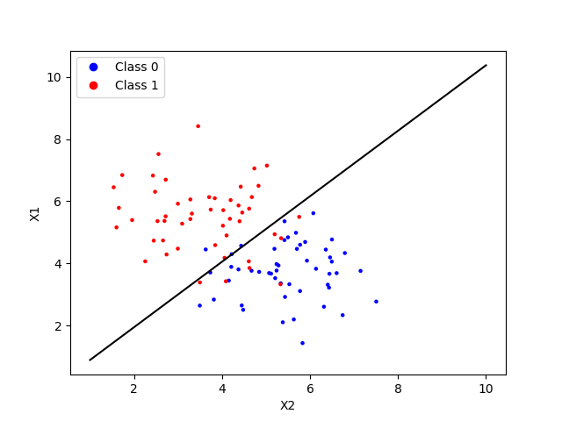

Equation of the decision boundary obtained is y = 1.0529x-0.1549

4. Gaussian Descriminant Analysis

4.a When Σ₀ = Σ₁

μ₀ = (-0.75529433, 0.68509431)
μ₁ = (0.75529433, -0.68509431)

Σ = [[ 0.42953048 -0.02247228]
[-0.02247228 0.53064579]]

4.b
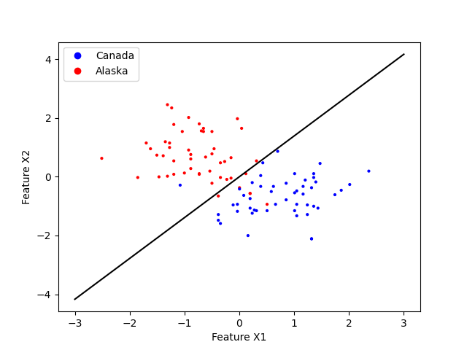

4.c Boundary Equation when Σ₀ = Σ₁

x^{T}Σ⁻¹(μ_{1 –} μ₀) = (μ₁^{T} Σ⁻¹ μ₁ - μ₀^{T} Σ⁻¹ μ₀) / 2 + log((1-ϕ) / ϕ)

Equation of linear boundary obtained is: y = 1.38984x + 4.552736453580601e-16

4.d μ₀ = (-0.75529433, 0.68509431)
μ₁ = (0.75529433, -0.68509431)

Σ₀ = [[ 0.38158978 -0.15486516]
[-0.15486516 0.64773717]]

Σ₁ = [[0.47747117 0.1099206]
[0.1099206 0.41355441]]

4.e Quadratic Boundary equation
2log(ϕ/(1-ϕ)) + log(|Σ₀|/|Σ₁|) + 2x^{T}Σ₁⁻¹μ₁ - 2x^{T}Σ₀⁻¹μ₀ + x^{T}Σ₀⁻¹x - x^{T}Σ₁⁻¹x + μ₀^{T}Σ₁⁻¹μ_{0 –} μ₁^{T}Σ₁⁻¹μ₁ = 0

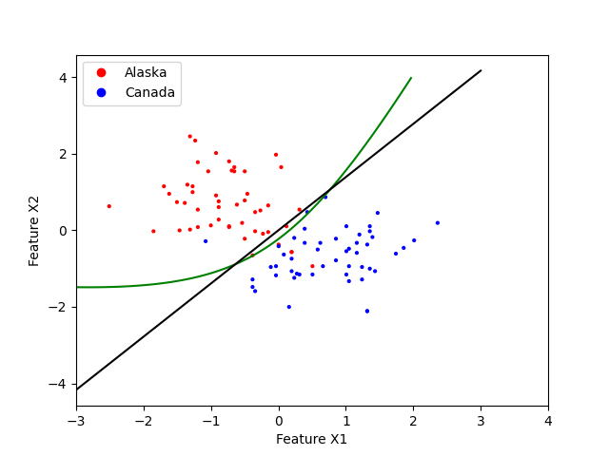

The following could be inferred from the above graph:
The linear boundary was not able to carefully label the boundary points but the quadratic
boundary obtained a reasonable seperation for the boundary points. This may have been
because in the quadratic case, we had taken different variance for both the labels which have
helped the model to generalize to the training examples.

